
Stonyman / Hawksbill Silicon Documentation

Stonyman and Hawksbill vision chips | Revision 0.1  August 10, 2011

NOTE: This is a working document being edited from a prior document. Text in GREEN is old and should be ignored.

1. General Description:
The Firefly series of vision chips are a series of flexible resolution vision chips designed for a broad set of visual sensing applications. Two chips are available in this series, the FireflyBig having a resolution of 480x256 pixels, and the FireflySmall having a resolution of 128x256 pixels. The general top-level features of chips in this series are as follows:
* Dual-mode pixel array, capable of operating in log-response mode or linear-response mode
* Switches within pixel array to allow binning by 2, 4, or 8 pixels, independently in each direction
* Direct addressing of pixels by row and column
* Row amplifier circuits
* On-chip 8-bit flash ADC, with internal reference voltage generators
* On-chip linear voltage regulator (external bypass capacitor recommended) for analog circuitry
* PIO12B interface

2. General Specifications:

Raw focal plane resolution | Stonyman: 112x112 (12,544)  Hawksbill: 136x136 (18,496)
Array type | Stonyman: Square array Hawksbill: Hawksbill: Hexagonal array arranged in ASA Form 1
Drawn die size | Stonyman: 4535um x 3665um  Hawksbill: 4095um x 3665um | Actual die size will be slightly larger due to cutting of reticle
Focal plane size | Stonyman: 2.8mm x 2.8mm  Hawksbill: 2.3mm x 32.7mm
Pixel pitch | Stonyman: 25 microns  Hawksbill: 20 microns | Square pixel array
Pixel circuitry | Logarithmic / continuous time pixel
Pixel binning | Stonyman: in-pixel connections to N, S, E, and W pixels  Hawksbill: None
Pixel amplifier | Seven-level switched capacitor circuit | May be bypassed to allow raw pixels to be read out
Interface | Counter based, with five digital inputs and one analog output
Process | X-Fab XC06
Power supply voltage | VDD=3.0V to 5.0V | Operation below about 4.0v requires the use of the amplifier to implement level shifting

3. Chip layout:
The following pages show the layout of the Stonyman and Hawksbill chips. The pad frame is identical for both chips, except for the fact that Stonyman is slightly taller.
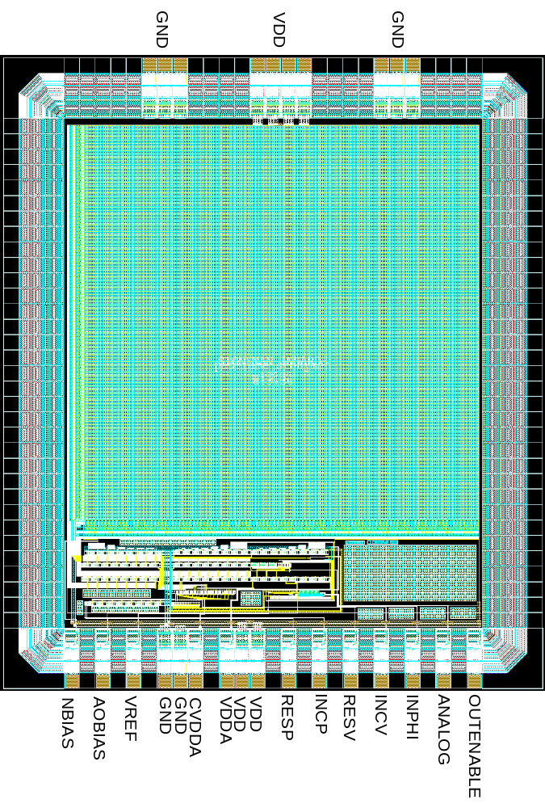
Stonyman
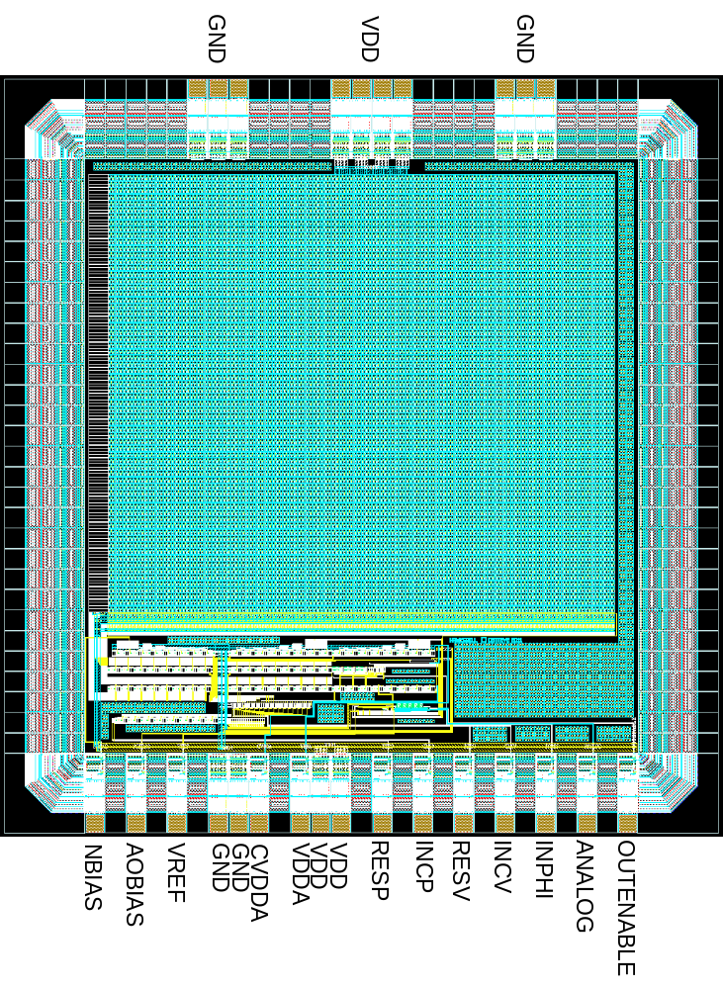
Hawksbill

4. List of pads / external signals:
Below is a list of all pads and external signals which is valid for all Stonyman and Hawksbill series chips. The pitch between pads is XXX microns. All pads having the same name are electrically connected on the chip. Most users will need to use only the subset of signals that are "black". Advanced and optional signals are in "blue" text.

Name | Type | Description
VDD | Power | Power supply to all portions of the chip except bias generators
GND | Power | Ground/substrate
RESP | Digital Input | Reset Pointer. Resets pointer register when pulsed. Active high.
INCP | Digital Input | Increment Pointer. Increments pointer register when pulsed. Active high.
RESV | Digital Input | Reset Value. Resets the active register (as selected by pointer register). Active high.
INCV | Digital Input | Increment Value. Increments the active register (as selected by pointer register). Active high.
INPHI | Digital Input | Operates amplifier. Rest state is low. Raise to reset amplifier, lower to generate amplified output.
ANALOG | Analog Output | Analog output of chip containing pixel signal. This gets sent to an ADC.
NBIAS | Bias | Supply for column readout circuits
AOBIAS | Bias | Bias for final output buffer amplifier
VREF | Bias | Reference voltage for amplifier circuit
VDDA | Bias generator power | Power signal for bias generators. Floating on power up, may be connected to VDD using the Config register.
CVDDA | Analog Power Control | Determines whether VDDA and VDD are shorted. When this signal is VDD, lines VDD and VDDA are disconnected. When this signal is GND, lines VDD and VDDA are connected. This signal is VDD on power up.
OUTENABLE | Digital Input | Functions as a “chip select” line. Connects output buffer amplifier to ANALOG pin when digital high. Internally pulled up to VDD. Pull down to GND to disconnect chip output.
5. Connecting a Firefly chip to power and to a processor:
The figure below shows a minimal connection between a Firefly vision chip and a processor operating it. This configuration is for when using the PIO12B interface in standard mode. Refer to documentation on the PIO12B interface for more details. If the processor and the Firefly vision chips will be operated from the same power supply, then VDD and VDDI may be shorted together. DO NOT let VDDI exceed VDD in potential. The VDD and VDDA power rails each should have at least one bypass capacitor between the power rail and ground. The optimal capacitances have not yet been determined, but it is suggested that at least a larger (1uF or above) capacitor be used for each of these. Additional capacitors and capacitance will not hurt the chip and will likely help. Note that on chip power up VDD and VDDA are internally shorted together by default, and are disconnected as part of setting up the linear regulator (see Section 8.2). Optionally one may externally short VDDA and VDD together.

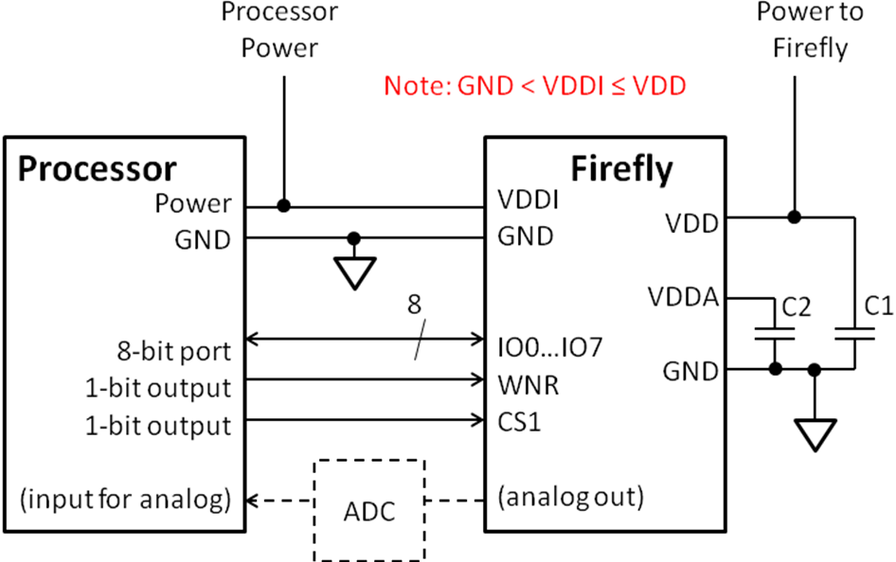 FIGURE OBSOLETE

6. Commands:
All Centeye vision chips using the PIO12B interface use 12-bit commands for all operations. These commands may be used to program on-chip biases, configure the chip for a particular operation, operate the chip itself, or select a specific pixel by row and column for readout. Each command may take the form of a three-bit header and a nine-bit argument, or a six-bit header and a six-bit argument. In both cases the headers form the most significant bits. Refer to the documentation of the vision chip for information on the specific command codes and their usage.
The vision chip may be connected in one of two ways: The default method is "standard PIO12B mode", in which the 12-bit commands are written to the vision chip in two six-bit sets. This may sound wasteful, however once the upper six-bits are written to the PIO12B interface, they are stored until overwritten again. In general there are only one or two commands that dominate 98% of the commands written, thus the upper six bit portion of the 12-bit command may be left untouched, thus requiring that only the lower six bits be sent. Therefore in practice the penalty is minimal.
The other method of connecting the vision chip is in "extended PIO12B mode", in which the 12-bit commands are written directly to the vision chip through separate signals CMD0...CMD11. Refer to Centeye documentation on the PIO12B interface for more details.

7. Chip Block Diagram:

7.1 Overview
The figure below shows a high level block diagram of the chip. The PIO12B module serves as the entry and exit point for communications with the chip. The PIO12B module sends 12-bit commands to registers that handle configuration, chip operation, and pixel selection for readout. Additional 12-bit commands control on-chip bias generators, some vaulted and some non-vaulted. Vaulted biases have a key circuit (the "vault") which must be enabled to allow them to be changed- this is a safety feature to prevent against setting of biases during operation.
The focal plane comprises a 480x256 or 128x256 array of pixel circuits, which are discussed further below. Row reset and row selection signals are generated on the left of the focal plane and are used to reset rows (when configured for use in linear mode) and to read out rows. There is one row reset and one row select line for each row of pixels. Column readout lines carry the output values of the selected pixels to the bottom of the focal plane. There is one column readout line for each column of pixels.
The pixel circuits in the focal plane contain switches to short out a pixel to the pixel on the right or above. This allows binning a block of pixels into one value for implementing "superpixels" from the raw pixel array.
At the bottom of the focal plane is a row amplifier array and a column selection circuit. The row amplifier array contains one amplifier for each column of the focal plane. These amplifiers may be used to amplify the voltage output by the focal plane before being output or sent to the ADC. Column select circuitry selects one column to be output from the array.
An analog buffer circuit buffers the selected pixel signal and sends it to the 8-bit flash ADC for conversion. If the "OUTENABLE" signal is high (e.g. WNR=0 and all CSs=1) then the buffered signal is also sent off chip to the ANALOG1 pad.
An 8-bit flash ADC converts the buffered pixel value into an 8-bit value that is sent to the PIO12B interface. When the chip is selected to be read, this 8-bit value becomes the digital output on lines IO0...IO7. Biases RESB and REST are the lower and upper reference voltages for the ADC. The signal SHORTYUKPHI allows the ADC to be operated directly from off-chip, bypassing the PIO12B module for speed. The ADC may also be operated through the PIO12B module.
A linear voltage regulator generates the VDDA power rail from VDD, and is also configured through the PIO12B.

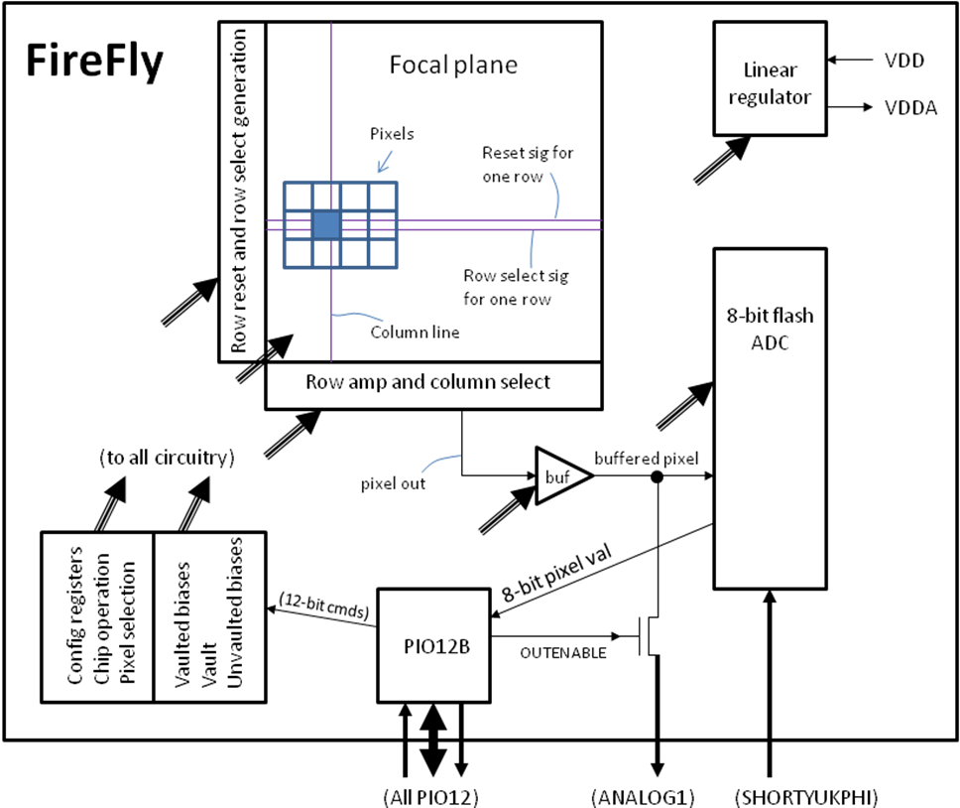

7.2 Pixel Circuit:
The pixel circuit is shown below. The light sensing element is N-well photodiode D1 (formed between an N-well and the P-substrate, the latter tied to ground). The function of M1 and M2 will be discussed below. The voltage generated by the pixel circuit is stored at the node with the circle (•). When the row select signal is high, the voltage is read out to the column line through transistors M3 and M4. The column line goes to transistor MC, which with the bias NBIAS and transistor M3 forms a source follower to output the pixel value. Note that there is only one MC transistor for each column line.
When the pixel circuit is operated in log response mode, the "row reset" signal is set equal to the potential determined by the PRSUPPLY bias generator. In logarithmic mode, all row select lines across the entire focal plane are connected together to PRSUPPLY. As light strikes the photodiode D1, it sinks current to the substrate (to ground) proportional to the amount of light striking it. This current is typically in the picoamp or nanoamp range. This small current flows through transistors M1 and M2. Due to the small current, these transistors are operating in the subthreshold region. When diode connected, the voltage drop across M1 and M2 will be a logarithmic function of the current flowing through them, and thus a logarithmic function of the intensity. When light changes by a factor of e=2.7, the voltage drop across M1 and M2 will change by about 100mV to 150mV. A large range of light intensities may thus be compressed within a manageable voltage swing.
When the pixel circuit is operated in linear response mode, the "row reset" signal is a digital signal and switches between VDD and GND, depending on the RESETROW signal. When RESETROW is high, the row select signal of the selected row will rise to VDD. This causes the pixel potential to charge up to a potential equal to VDD minus the voltage drop across M1 and M2. This charge is held across parasitic capacitances in D1, M3, and other components. When RESETROW is lowered, the row select signal of the selected row will fall to GND. As light strikes diode D1, the pixel potential will drop. Over a period of time, which we shall refer to as the integration interval, the potential across D1 will fall by an amount equal to the integral of the light striking D1 over time. This voltage may then be read out to the column line by selecting the row select signal. A "rolling shutter" mechanism may be used to vary the integration interval of the chip while reading out pixel values.
If one is clever, one may use a combination of both modes as follows: While operating the pixel circuit in linear mode, first reset the row. Then read out the entire row. The voltage signal read will be the log-compressed version of the pixel value. Then lower the reset line and allow the charge to integrate. The potential may then be read out in linear mode. We have not yet attempted this combination mode, but there is no reason it should not work if careful timing is observed.
The signals vsw and hsw may be used to electrically connect a pixel circuit to the pixel circuits above or to the right. This allows groups of pixels to be "binned" together to form "superpixels" covering a larger portion of the focal plane. Instructions on how to perform binning are provided below.
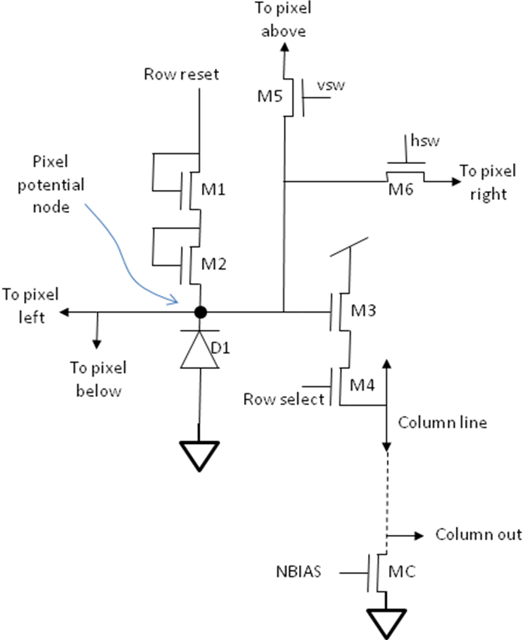

7.3 Row Amplifier Circuit:
The row amplifier array contains one amplifier circuit for each column line. This amplifier circuit allows the column signals to be processed by one of three ways.
If SELAMP is high, then the column signal is amplified using an adjustable gain switched capacitor circuit. Essentially the switched capacitor circuit compares the column voltage with bias VREF. The polarity of the inputs may be as shown in the figure or swapped. The amplifier may be configured for one of four gains.
If SELPBUF is high, then the column signal is shifted up by about a volt using a PMOS-based source follower. The voltage gain of this amplifier is slightly less than one.
If SELRAW is high, then the column signal is sent out without amplification or shifting.
If the appropriate column is selected, then the output value is sent out to the pixel buffer circuit, and then to either the ADC or off-chip. Column select circuitry allows only one column to be selected at a time.
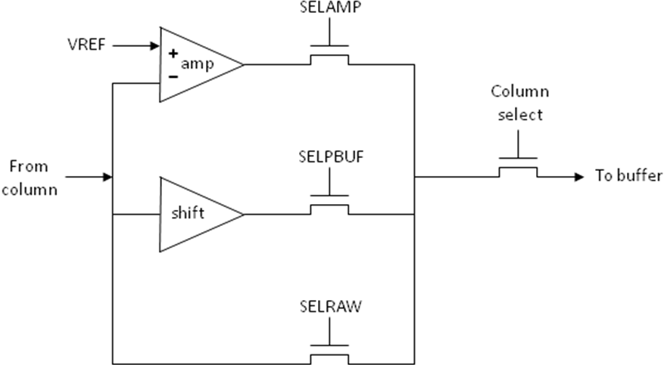

The schematic diagram of the switched capacitor amplifier is shown below. This is a classic switched capacitor circuit. This circuit may be operated as follows:

Step 1: set phi=1 and nphi=0. This shorts together the inverter input and output.

Step 2: set scref1=1, scin1=0, scref2=1, and scin2=0. This connects the left sides of capacitors C1 and C2 to the reference voltage VREF. We recommend adding a delay of several microseconds after this step.

Step 3: set phi=0 and nphi=1. This stops shorting the inverter input and output.

Step 4: set scref1=0, scin1=1, scref2=0, and scin2=1. This connects the left sides of capacitors C1 and C2 to the input column voltage. We recommend adding a delay of several microseconds after this step.

A short period after Step 4, the circuit will output an amplified version of the column voltage with a value approximately equal to:
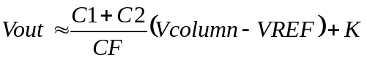
where C1, C2, and CF are the values of the corresponding capacitors and K is from the potential of the inverter when it's input and output are shorted together. Different levels of amplification may be obtained by switching just C1 or just C2. To exclude one of these capacitors, just keep the left-hand side connected to VREF. For example, to exclude C2 and use just C1, then modify Step 4 so that scref2=1 and scin2=0.
Clearly VREF needs to be set to the proper voltage in order for the amplifier circuits to not saturate. Too high or low a value of VREF will result in some or all pixels being saturated. Some trial and error may be needed to find the proper value of VREF.
In order to reverse the sign of the amplification, it is possible to reverse the order which the left-hand sides of capacitors C1 and/or C2 are connected. This may be accomplished by swapping Step 2 and Step 4 above.
The values of the capacitors are about as follows: CF=153fF, C1=400fF, and C2=705fF. Using just C1 for amplification thus provides a gain of about 2.6. Using just C2 provides a gain of about 4.6. Using both C1 and C2 provides a gain of about 7.2.

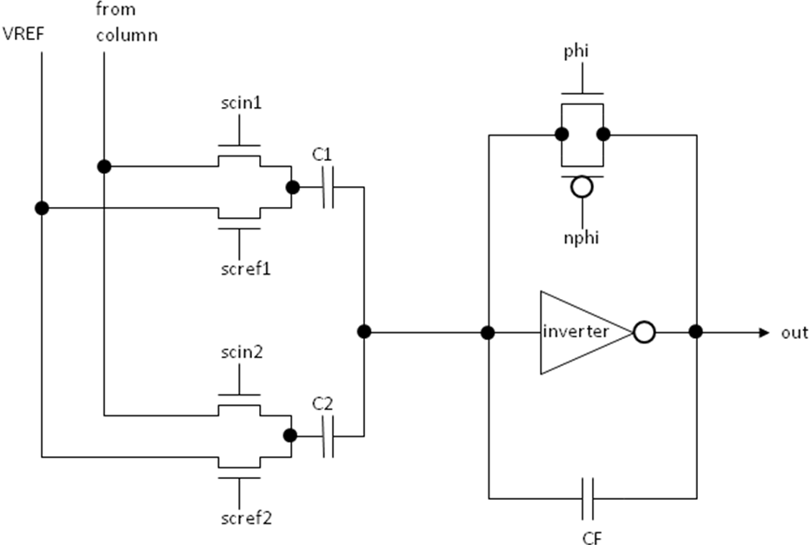
8. Operation of individual components:
This section discusses the operation of individual components and modules of the chip. The instructions and commands are presented below in the general order of operation for a sample application, and with increased functionality towards the end of this section.

8.1 Sending commands to the chip:
The four digital input signal RESP, INCP, RESV, and INCV are used to configure chip system registers. All configurations may be performed by pulsing these four signals in proper sequence. The figure below shows a behavioral model of these registers. The resting state for these four signals is digital low (GND). The active state is digital high (VDD). When we refer to one of these four signals as being “pulsed”, we mean that the signal is pulsed high, e.g. raised from digital low to digital high, held high for a small duration (nominally a few hundred nanoseconds), and lowered back to digital low.
Two rules should be followed when pulsing these four signals. First, always return the signal back to digital low before doing anything else. Second, do not pulse more than one signal at a time. No more than one of these signals should be a digital high at any one time or the chip may behave in strange ways.
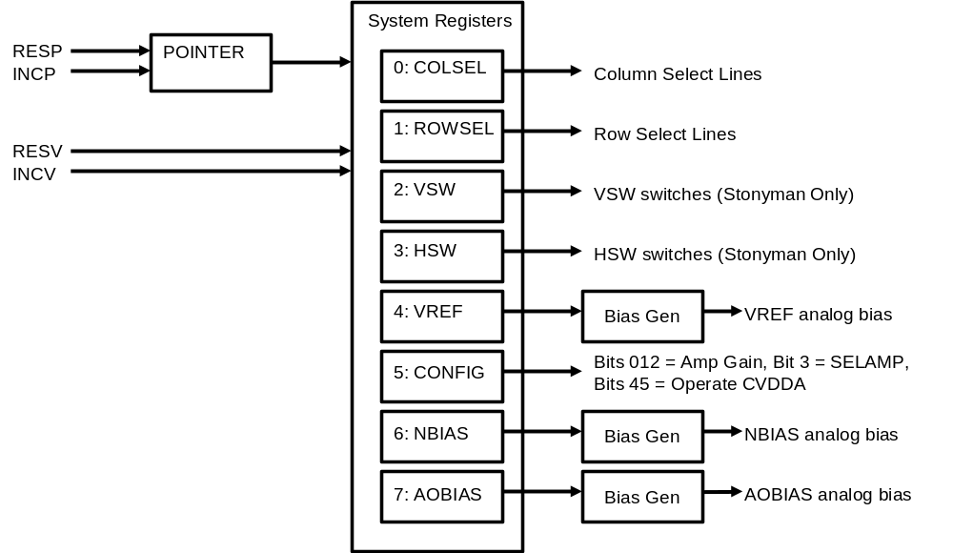

The four signals RESP, INCP, RESV, and INCV can be thought of as follows:
RESP = “Reset Pointer”
INCP = “Increment Pointer”
RESV = “Reset Value” (e.g. reset active register)
INCV = “Increment Value” (e.g. increment active register)

There are a total of eight system registers, numbered from 0 to 7. More commonly used system registers are given a lower number. The POINTER register determines which of the system registers are active at any one time. When signal RESP is pulsed, the POINTER register is reset to value “0”. This causes the COLSEL register (register 0) to be active. When signal INCP is pulsed, the POINTER register increments in value. This will activate a different system register. For example, to make the system register HSW (register 3) active, first pulse RESP and then pulse INCP three times.
When a system register is active, it may be similarly reset or incremented using the RESV and INCV signals. Pulsing the RESV signal will reset the active system register to zero. Pulsing the INCV signal will increment the active system register by one.
For example, if we want to set system register ROWSEL to 10, we could do the following steps:
Step 1: Pulse RESP (to reset POINTER)
Step 2: Pulse INCP once (to make ROWSEL active)
Step 3: Pulse RESV (to reset ROWSEL to zero)
Step 4: Pulse INCV 10 times (to set ROWSEL to 10)
Note that if a system register is not active, and then later made active, it is not necessary to reset that system register before setting it to a new value. It will hold its current value until you reset it or increment it. For example, suppose COLSEL is currently set to 20, and the currently active system register is ROWSEL. If you want to increment COLSEL to 22, you only need to first pulse RESP to reset POINTER and make COLSEL active, and then pulse INCV twice to increase COLSEL from 20 to 22.
The POINTER register holds its value in a similar manner. For example, suppose POINTER=3 which makes HSW the active system register, and you want to adjust the VREF register (to set the VREF bias). You could first pulse INCP to increment POINTER and make VREF active, and then operate RESV and/or INCV as need to select the new value of VREF.

8.2 Turning on the chip:
The following steps are recommended to configure the chip on power-up:

Step 1: Configure the biases
Set NBIAS and AOBIAS to their respective values. For 5V operation we recommend experimenting with values between 55 and 60 for both of these.

Step 2: Set binning switches (Stonyman only)
If binning WILL NOT be used, then clear the VSW and HSW registers.
If binning WILL be used, then set VSW and HSW to their desired values.

Step 3: Configure

If the amplifier WILL NOT be used, then set CONFIG to the following value:
CONFIG = 16
This configures the pixel amplifier to be bypassed. The “16” connects the VDD and VDDA signals, which turn on the chip.

If the amplifier WILL be used, then set CONFIG to the following value:
CONFIG = Gain + 8 + 16
The value “Gain” must be between 1 and 7 and selects the gain of the amplifier. (Setting Gain=0 results in that- zero gain or no output. Duh.) The value “8” configures the pixel amplifier to be inserted. The “16” connects the VDD and VDDA signals, which turn on the chip.

8.3 Reading pixels from the chip

To read a pixel from the chip, generally you perform the following:

Step 1: Select row and column by setting ROWSEL and COLSEL registers to their proper values.
Note that you do not need to reset and set both of these registers every time you grab a pixel. In most cases, you will only need to increment one or other of these registers.

Step 2: Operate Amplifier. (Skip this step if amplifier is not being used e.g is bypassed)
Set INPHI = high
Delay (empirically determined, about a microsecond)
Set INPHI = low

Step 3: Read pixel
First delay a small amount (empirically determined, start with a couple microseconds) and then digitize the analog signal at ANALOG.

8.4 Bias generators:
For operation at about 5V, the following bias settings are recommended:

NBIAS: Between 55 and 60

AOBIAS: Between 55 and 60

VREF: Between 40 and 55 (some trial and error needed)

8.4 Configuring and using the 8-bit flash ADC:

Registers:
RESB: Bias generator to generate lower reference voltage
REST: Bias generator to generate upper reference voltage
YUKNBIAS: Bias generator for Yukawa latch. NOTE: this voltage cannot be too high a voltage / too low a value or else the chip will draw significant amounts of current!
ADCOP: Configuration and operation of the ADC.
(Bit 0) YUKPHI: "0" to reset the ADC, "1" to initiate a conversion
(Bit 1) CONNECTADCIN (legacy): Must be "0" for proper operation.
(Bit 2) SHORTRESB: When set to "1" this tends to short the RESB bias to GND. The effect is weak and thus this feature is best not used, e.g. just leave this value set to "0".

Basic mode: Operation via PIO12B
To operate the ADC via the PIO12B module, send the following commands. The variable pixel_value, which is an unsigned byte, will contain the digitized pixel value at the end of this sequence.

// Note: RESB and REST commands need only be sent once
Send (RESB+63); // This sets RESB to the lowest possible value. May be changed
Send (REST+0); // This sets REST to the highest possible value. May be changed
// The remaining commands are sent once for each pixel conversion
Send (ADCOP+0); // Reset ADC. Ideally do this before a new pixel value is selected
// <== insert code to select a pixel by row and column here ==>
Send (ADCOP+1); // Start ADC conversion
pixel_value = Receive(); // pixel_value will contain the 8-bit digitized pixel

Basic mode: Operation via the SHORTYUKPHI signal
Slightly faster operation may be obtained by using the SHORTYUKPHI signal, which is an input signal to the chip. Recall that this signal is internally pulled down. To use this mode, first the YUKPHI signal needs to be set high. Then the SHORTYUKPHI signal may be used to pull YUKPHI down. This may be performed as follows:

// The following three commands need to be sent only once
Send (RESB+63); // This sets RESB to the lowest possible value. May be changed
Send (REST+0); // This sets REST to the highest possible value. May be changed
Send (ADCOP+1); // Turn YUKPHI on. This only need to be performed once
// The following commands are sent once for each pixel conversion
SHORTYUKPHI = 1; // Reset ADC. The processor must directly control this input signal
// <== insert code to select a pixel by row and column here ==>
SHORTYUKPHI = 0; // Start ADC conversion
pixel_value = Receive(); // pixel_value will contain the 8-bit digitized pixel

8.5 Log response mode:
The log response mode is the easier of the two methods to implement. In this mode, diode D1 and transistors M1 and M2 operate in continuous time to generate a voltage indicating intensity. This voltage may then be read any time desired. Since, unlike the linear mode, the pixel is not discharged between frames, this mode is in fact more sensitive in low light levels and allows for acquisition at a higher frame rate. The two disadvantages of the log response mode are that 1) the contrast sensitivity is reduced, and 2) the "fixed pattern noise" can be large and can change with chip operating temperature. The row amplifier circuits (discussed further below) can be used to overcome the first disadvantage to some extent.
The following commands may be used to configure the Firefly chip for log response mode using no row amplification. For this particular set of modes, the commands below need to be sent only once.

// Turn off all binning switches in vertical and horizontal directions
Send (VSW+0);
Send (HSW+0);
// Set row amplifiers to straight output e.g. no amplification This part will be changed if we are
// going to use the row amplifers to amplify the signals, as discussed in Section 8.7
Send (AMPCONF+12); // SHORTCAP=1, SELRAW=1, SELAMP=0, SELPBUF=0
Send (AMPOP+1); // TURN OFF SWITCH CAP AMPLIFIER
// Configure focal plane
Send (FPCONF+4); // RESETROW=0, READROW=1, ENABLERESET=0, NCONNPRS=0

To read out an image of pixels, simply loop through the rows and columns and digitize each pixel one at a time. The example below shows how one would read out the entire pixel array of the FireflySmall chip. Note the use of the Delay() function at appropriate times. Note that this segment of code digitizes the pixel using the on-chip ADC being operated through the PIO12B, as discussed above.

For row = 0...127 do loop
Send (ROWSEL+row); // Select row
// Delay- this delay value is suggested but not verified to be optimal
// Note- if we are going to use the row amplifiers to amplify the column signals, as
// discussed in Section 8.7 below, the delay instruction below will be replaced with
// other instructions.
Delay(3);
For column = 0...255 do loop
Send (ADCOP+0); // Reset ADC.
Send (COLSEL+column); // Select column
Delay(1.5); // Delay- this value is suggested but not verified to be optimal
// Below we digitize the pixel, using one of the methods discussed above
Send (ADCOP+1); // Start ADC conversion
Delay(0.2); // Delay- this value is suggested but not verified to be optimal
pixel_value[row,column] = Receive(); // Store pixel value in array
end loop
end loop.

Notes:
1) Note that it is not necessary to loop through every single pixel- one can skip rows and/or columns, and one can choose to read out just a block of pixels rather than the entire array.
2) The delay values above are suggested, but have not been verified to be optimal. In general a longer delay yields a better result, but slows down image acquisition.

8.6 Linear response mode:
The linear response mode is more similar to that of traditional "active pixel sensors" (APS). In this mode, the photodiode is charged up to a reset potential, and then over an integration period the photodiode discharges as light strikes it. The resulting charge at the end of the integration period is a linear function of the integral of the amount of slight striking the pixel- More light or a longer integration period will result in more discharge and a lower resulting potential. Note that unlike the logarithmic response mode, in this mode the pixels can saturate if the integration period is too long or the intensity is too bright.
The following set of instructions prepare the Firefly chip for operation in linear response mode.

// Turn off all binning switches in vertical and horizontal directions
Send (VSW+0);
Send (HSW+0);
// Set row amplifiers to straight output e.g. no amplification.
Send (AMPCONF+12); // SHORTCAP=1, SELRAW=1, SELAMP=0, SELPBUF=0
Send (AMPOP+1); // TURN OFF SWITCH CAP AMPLIFIER
// Configure focal plane
Send (FPCONF+3); // RESETROW=0, READROW=0, ENABLERESET=1, NCONNPRS=1

Now we show how to operate the chip and read out an image. We are using a "rolling shutter", where a row is first digitized and then reset. This process is performed through every row being read out. The first frame acquired will be junk, however the second and every frame thereafter will be valid. This is because the resetting of the row, by pulsing the reset line at the bottom of the code segment, is required to "discharge" the row of pixels. Then in the time period between that and the next time that row is read out, the pixels would integrate charge according to the amount of light striking them. The next time the code segment below is executed, the image read out will be valid. The integration period is thus the amount of time required to read out one frame. The instructions below show how to read out a frame:

For row = 0...127 do loop
// The instruction below is not necessarily required but is good practice
Send (FPCONF+3); // RESETROW=0, READROW=0, ENABLERESET=1, NCONNPRS=1
// Now we read the row
Send (ROWSEL+row); // Select row
// The next command outputs the current pixel values to the column lines
Send (FPCONF+7); // RESETROW=0, READROW=1, ENABLERESET=1, NCONNPRS=1
// Now we read out the row
Delay(3); // Delay- this delay value is suggested but not verified to be optimal

For column = 0...255 do loop
Send (ADCOP+0); // Reset ADC.
Send (COLSEL+column); // Select column
Delay(0.2); // Delay- this value is suggested but not verified to be optimal
// Below we digitize the pixel, using one of the methods discussed above
Send (ADCOP+1); // Start ADC conversion
Delay(0.2); // Delay- this value is suggested but not verified to be optimal
pixel_value[row,column] = Receive(); // Store pixel value in array
end loop
// Next we stop reading out the row
Send (FPCONF+3); // RESETROW=0, READROW=0, ENABLERESET=1, NCONNPRS=1
// Now we reset the row, using a rolling shutter. This command raises the row reset line
Send (FPCONF+11); // RESETROW=1, READROW=0, ENABLERESET=1, NCONNPRS=1
// Finally lower the reset line
Send (FPCONF+3); // RESETROW=0, READROW=0, ENABLERESET=1, NCONNPRS=1
end loop.

Notes:
1) If the environment is too dark, then the integration period needs to be increased. This may be accomplished by adding a large delay at the end of the frame readout sequence. This delay may be inherent in other algorithms that process the imagery.
2) If the environment is too bright, then the integration period needs to be decreased. This may be performed by resetting a different row than being read out. For example, after reading out and digitizing row i, we can then reset row i+N, where N may be one, five, fifty, or another number. This shortens the integration interval.
3) Timing: Obviously timing is important- we either need to make sure every integration period is the same, or that we use some sort of timer to measure the integration period. The latter may be needed if the processor operating the vision chip gets "interrupted" by communications requests. The acquired intensity may then be scaled according to the actual integration interval for that row.
4) A large amount of flexibility is allowed regarding integration intervals. Each row may be given a separate integration interval, which allows different rows to have different sensitivities.

8.7 Operation of row amplifiers:
The row amplifiers allow the column readout lines to be amplified, which effectively enhance the contrast. Generally speaking, the row amplifers are used for the log response mode, since the log response mode generates a small signal due to logarithmic compression. The operation of these circuits is discussed above in Section 7.3, therefore here we will just list the commands needed to operate these circuits.
First, we need to configure the row amplifier circuits to amplification mode. Using the code of Section 8.6 as a base, we would replace the instruction:

// Old instructions
Send (AMPCONF+12); // SHORTCAP=1, SELRAW=1, SELAMP=0, SELPBUF=0

with the following new instructions:

// New instructions
Send (AMPCONF+2); // SHORTCAP=0, SELRAW=0, SELAMP=1, SELPBUF=0
Send (VREF+VVV); // Set VREF to a voltage. VVV is obtained empirically.
// We suggest starting with VVV=63 and decreasing until
// a good value is obtained. Note that VVV may be need to be
// adjusted if the sensor moves from a bright environment to a
// darker one or vice versa, since the amplification reduces
// dynamic range.

Second, we will need to add instructions to amplify the row of column signals before they get read out. To do this, replace the following instruction, which occurs right before cycling through columns:

Delay(3); // Delay- this delay value is suggested but not verified to be optimal

with the following set of instructions:

Send (AMPOP+42); // Connect caps to VREF, set PHI=1 and NPHI=0 to short inverter
Delay(4); // This delay value is suggested. Try between 0.5 and 5.
Send (AMPOP+41); // Set PHI=0 and NPHI=1. This should be performed BEFORE the next step
Send (AMPOP+XXX); // Connect one or both caps to column output. See below for XXX
Delay (4);

The value of XXX is as follows: To use just C1 for minimum gain, then XXX=37. To use just C2 for medium gain, then XXX=25. To use both C1 and C2 for maximum gain, then use XXX=21. After a short delay, the row amplifiers should output the correct amplified voltages.
Note that it may take some experimentation to determine the correct value of VVV for setting VREF. As suggested above, try starting with 63 and decreasing until all pixels are in range e.g. no pixels are obviously saturated.
8.8 Pixel binning to form superpixels:
The above examples assume that the Firefly chip is being read out at raw resolution. By using the VSW and HSW commands, it is possible to close the vsw and hsw switches in the focal plane pixel circuits according to a specified pattern. The VSW and HSW command each specify an 8-bit pattern that is repeated across the corresponding direction.
The HSW command is used to close "horizontal" switches. Setting HSW to binary pattern 00000001, for example, closes the hsw switches between columns 0 and 1, between columns 8 and 9, between columns 16 and 17, and so on. Binary pattern 10000000 closes the hsw switches between columns 7 and 8, 15 and 16, and so on.
The VSW command is used to close the "vertical" switches. Setting VSW to binary pattern 1000000 closes the vsw switches between rows 6 and 7, between rows 14 and 15, and so on. Binary pattern 01000000 closes the vsw switches between rows 5 and 6, between 13 and 14, and so on. Binary pattern 00000010 closes the vsw switches between rows 0 and 1, rows 8 and 9, and so on. Binary pattern 00000001 closes the vsw switches between rows 7 and 8, rows 15 and 16, and so on. The mapping of VSW onto the array is rotated by one due to the fact that in the pixel circuit, the vertical switch connects to the upward pixel and not the downward pixel.
To configure the focal plane to bin the pixels into 2x2 blocks, one would send the following commands:

Send (HSW+b10101010); // Note: "b" prefix indicates binary number
Send (VSW+b01010101);

The above commands would only need to be sent once. Each of these 2x2 blocks may be referred to as a "superpixel". To configure the focal plane to bin the pixels into 4x4 blocks, one would need to send the following commands:

Send (HSW+b11101110);
Send (VSW+b01110111); // Note rotation by one

Finally, to configure the focal plane to bin the pixels into 8x8 blocks, one would need to send the following commands:

Send (HSW+b11111110);
Send (VSW+b01111111);

Note that it is possible to bin the pixels by different amounts in each direction. Thus it is possible to bin the pixels into MxN blocks, where M and N may be 1, 2, 4, or 8. This allows the formation of rectangular superpixels. It is also possible to short out entire rows or columns across the entire focal plane by sending b11111111 to the appropriate VSW or HSW register.
Once the pixels have been binned, operating the focal plane and reading out the pixels may be performed as above. The difference is that it is only necessary to digitize one pixel value from each block. For example, if VSW and HSW are set to bin the array into 8x8 blocks of superpixels, then only every eighth row and pixel needs to be read out. This can speed up the acquisition of a frame by 8x8=64.

Notes:
1) It should be obvious from prior examples, but we state it here: setting VSW and HSW to all zeros will turn off binning.
2) When binning, it is preferable to read out the same pixel from each block frame after frame. This is because the fixed pattern noise is partially dependent on which readout transistor (transistor M3) and which column bias transistor (transistor MC) is being used. Thus using the same pixel every time keeps this fixed pattern noise constant.
3) When operating the array in linear mode, it is necessary to apply a reset to just one row of the pixel circuits. This is because the pixels are shorted together which spreads the "reset" all throughout the block. However it may be advantageous to hold the reset line high for a few microseconds to ensure the spreading is maximally applied.
4) It is possible to use a different binning for each frame. In logarithmic response mode, once the VSW and HSW arrays are changed a delay may be necessary to let the pixel circuits settle to the new values. This delay time will be shorter in brighter environments. At the current time we have not yet measured the delay necessary for each intensity level. In linear response mode, the act of resetting pixels is already part of the readout process so no new steps will need to be taken.
5) Binned pixel values may be amplified by the row amplifier in the same manner as raw pixels by incorporating the instructions of Section 8.7.

8.9 Comments on Fixed Pattern Noise (FPN):
Fixed pattern noise (FPN) is inherent in all image sensor circuits. FPN refers to offsets between identically drawn pixel circuits that result from process variations. FPN manifests itself as a noise-like pattern that appears when an image sensor is provided with a uniform intensity. Ideally fixed pattern noise is measured once and then stored in memory. Then when a new frame is acquired, the stored FPN image is subtracted from the acquired image to produce a clean image.
Unfortunately, FPN is a function of pixel mode, amplification type (raw or amplified, including amount of gain used), and binning methods. A different FPN mask will need to be acquired for each of these permutations.

9. Register List:
Below is a list of the eight registers and their meaning.

Register # | Name | Function
0 | COLSEL | Column Select  Stonyman: bits 6 to 0 select the column  Hawksbill: bits 7 to 0 select the column
1 | ROWSEL | Row Select  Stonyman: bits 6 to 0 select the row  Hawksbill (ASA format): bit 0 selects ASA value “a”, bits 7 through 1 select ASA value “r”  Hawksbill (2D format): bits 7 to 0 select the row
2 | VSW | Vertical switches (Stonyman Only)  Bits 0 to 7 determine respectively signals VSW0 to VSW7
3 | HSW | Horizontal switches (Stonyman Only)  Bits 0 to 7 determine respectively signals HSW0 to HSW7
4 | VREF | Reference voltage. 0 = highest voltage, 63 = lowest.
5 | CONFIG | Configuration Register  NOTE: This is the only “complicated” register that supports multiple functions  Bits 2 to 0 determine amplifier gain  Bit 3 determines whether amplifier is used: 1 mean use amplifier, 0 means bypass  Bits 5 and 4 operate CVDDA. To connect power signal VDD to VDDA, and thus turn the chip on, set bit 4 to 1 and bit 5 to 0  If the value of this register is changed, all three variables must be selected properly for the chip to operate.
6 | NBIAS | NBIAS voltage. 0 = highest voltage, 63 = lowest.
7 | AOBIAS | AOBIAS voltage. 0 = highest voltage, 63 = lowest.

10. Sample Instruction Sequences:
We will add this section in future versions based on questions from initial users.

Erreta / Version Changes:

Version 0.0, August 10, 2011: Pre-release working document

Version 0.1, August 10, 2011: Pre-release working document
* Added Sections 3 and 8.1

Disclaimer:

The information in this document is provided in connection with Centeye products. No license, express or implied, by estoppel or otherwise, to any intellectual property right is granted by this document or in connection with the sale of Centeye products. EXCEPT AS SET FORTH IN CENTEYE’S TERMS AND CONDITIONS OF SALE, CENTEYE ASSUMES NO LIABILITY WHATSOEVER AND DISCLAIMS ANY EXPRESS, IMPLIED OR STATUTORY WARRANTY RELATING TO ITS PRODUCTS INCLUDING, BUT NOT LIMITED TO, THE IMPLIED WARRANTY OF MERCHANTABILITY, FITNESS FOR A PARTICULAR PURPOSE, OR NON-INFRINGEMENT. IN NO EVENT SHALL CENTEYE BE LIABLE FOR ANY DIRECT, INDIRECT, CONSEQUENTIAL, PUNITIVE, SPECIAL OR INCIDENTAL DAMAGES (INCLUDING, WITHOUT LIMITATION, DAMAGES FOR LOSS OF PROFITS, BUSINESS INTERRUPTION, OR LOSS OF INFORMATION) ARISING OUT OF THE USE OR INABILITY TO USE THIS DOCUMENT, EVEN IF CENTEYE HAS BEEN ADVISED OF THE POSSIBILITY OF SUCH DAMAGES. Centeye makes no representations or warranties with respect to the accuracy or completeness of the contents of this document and reserves the right to make changes to specifications and product descriptions at any time without notice. Centeye does not make any commitment to update the information contained herein. Centeye’s products are not intended, authorized, or warranted for use as components in applications intended to support or sustain life.

